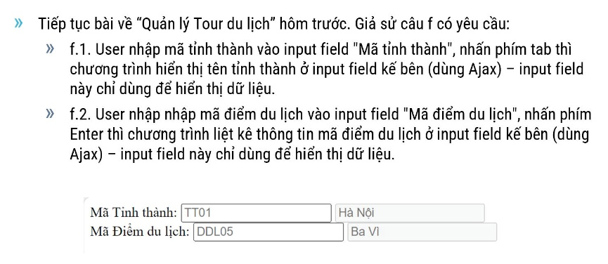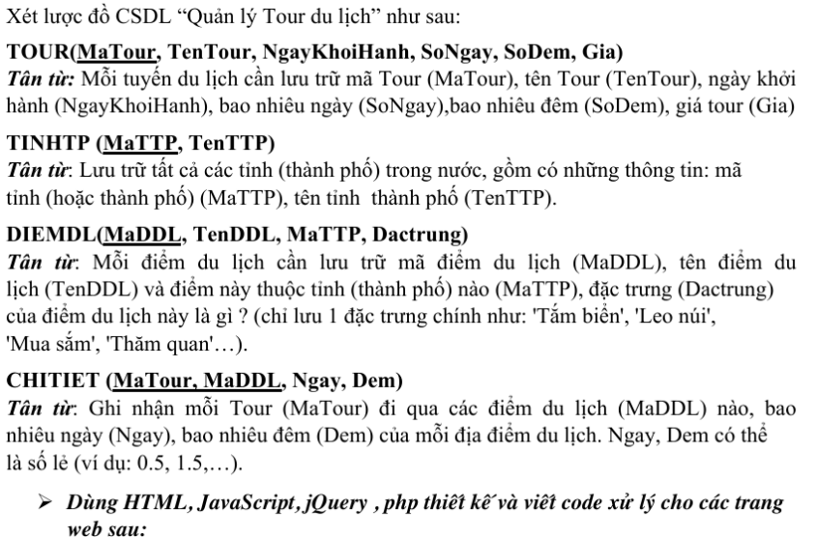

**Câu 2:**

**Câu 3:**

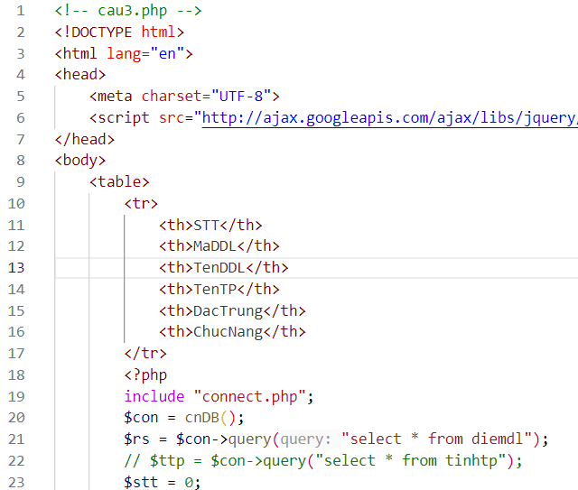

**Câu 4:**

**Câu 5:**

Câu f:

